3.a) Analysis Model

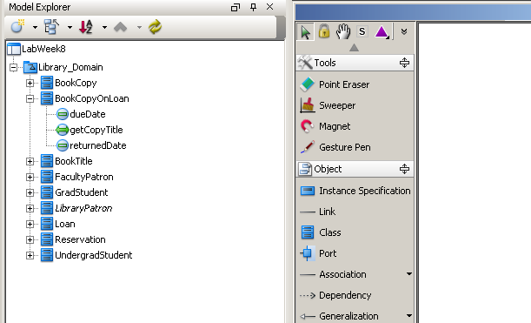

b) Use Case - **Find Book Titles on Loan by a Patron.**

Use case: **Find Book Titles on Loan by Patron**

Actors: Library patron.

Purpose: To find book titles .

Overview: Patron wants to find book titles that he has on his loan. Patron provides required details and system displays titles.

Type: Normal.

Preconditions: User (Patron) must be registered with library.

Postconditions: None.

Special requirements: None.

**Flow of Events**

**ACTOR ACTION SYSTEM RESPONSE**

1. Use case starts when patron desires to  
 check books on his loan.

2. Patron provides his loanId number

3. System checks book titles and responses to the patron. Patron is presented with books’ title.

**Alternative Flow of Events**

Line 3: Invalid/not existing loan id number. Indicate error and return to step 2.

c) collaboration - **Find Book Titles on Loan by a Patron.**

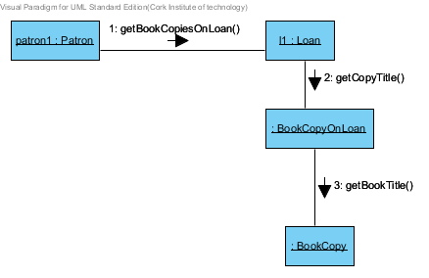

d) Use case Diagram - **Library**

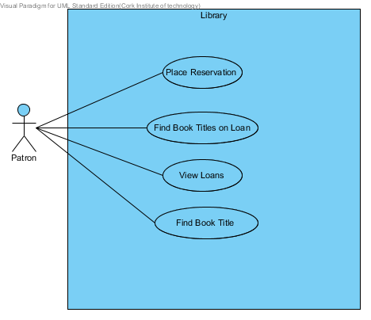

e) Class Diagram - **Library**



f) Object diagram - **PatronLoans**

